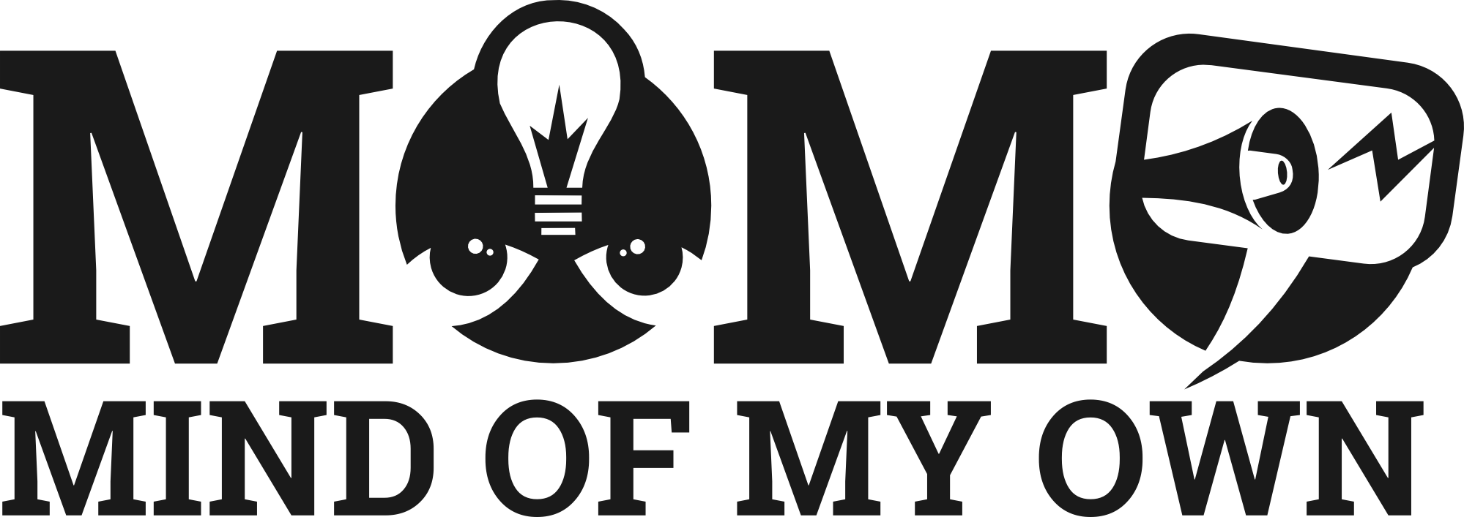

MOMO is an award-winning app that helps 8-21 year olds in contact with social care services to express their views, get more involved in meetings and make better decisions.
It delivers to IROs and social workers a verbatim statement of their views, saving time, improving engagement and increasing attendance at meetings.
It will be launched in your area this autumn/winter.

How does the app work?
MOMO works on nearly any device – mobile or computer. It can be used anytime the child has a meeting, a problem needing help or an idea to improve their care.
It guides them through a process of working out their thoughts, views, wishes and feelings, turning them into a statement and then giving the option to send it to a worker.
They can use it on their own, with a worker, or a foster carer or family member.

What difference does it make?
Workers who have used it in 1-1 meetings increased flow of conversation, better engagement in decision making and increased attendance at meetings.
They also report time saved in writing up young people’s views and satisfaction at how easy it is to understand their statements.
Young people can also use it solo anytime they need to get things off their chest or to alert workers to a problem.

What to do next
On your go live date you’ll receive information about how to introduce MOMO to your young people:
- On a work device
- On a foster carer’s device
- On the young person’s own device
If you’d like a peek at this information go to www.mindofmyown.org.uk/support.

